OSLab
Program 1
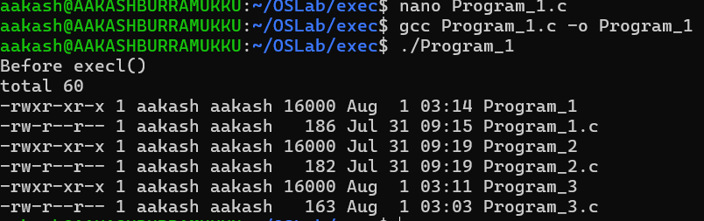
Program 2
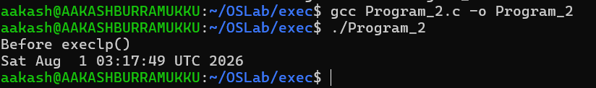
Program 3
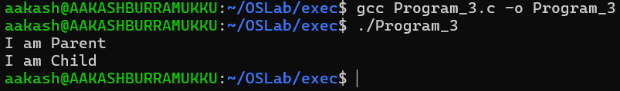
Program 4
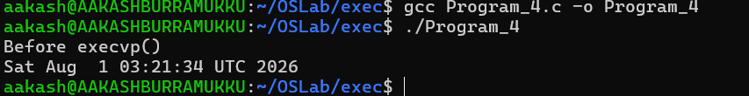
Program 5

